

# GOVERNMENT ARTS COLLEGE (AUTONOMOUS), COIMBATORE – 18. DEPARTMENT OF PHYSICS

A PROJECT REPORT ON

TABLEAU HR SCORECARD : MEASURING

SUCCESS IN TALENT MANAGEMENT



BASED ON

THE

COURSE



FUNDAMENTALS OF DATA

ANALYTICS WITH TABLEAU

-

SMARTBRIDGE

## SUBMITTED BY

|  |  |
| --- | --- |
| **SANTHOSH S** | **bru001221BST054** |
| **SURYA PRAHASAN R** | **bru001221BST060** |
| **VARATHARAJ R** | **bru001221BST061** |

**KESA VINOTHINI N bru001221BST012**

# TEAM ID – NM2023TMID25062

UNDER THE GUIDANCE OF

**Dr.G.K.BALACHANDRAN** M.Sc., M.Phil.

ASSISTANT PROFESSOR

## DEPARTMENT OF STATISTICS

SUBMITTED TO

**NAAN MUDHALVAN – SMART INTERNZ**

### DATA ANALYTICS UPSKILL PROGRAMING



*Dissertation submitted in partial fulfilment of the requirements for the course of*

FUNDAMENTALS OF DATA ANALYTICS WITH TABLEAU -



SMARTBRIDGE

**NAAN MUDHALVAN IDs :**

SANTHOSH S 9C8FB7F77A161B48C464ED95B7D700A5

SURYA PRAHASAN R 4737AEF316172F2A46F43623F09CF0A1

VARATHARAJ R C8503B44EFABA42A10344D0A3AA89C2C

KESA VINOTHINI N 88CCDDEB2CF7F2083BD4EB430009A8B3

### ACKNOWLEDGEMENT

We express our sincere and profound gratitude to our Principal **Dr.R.Ulagi M.Sc., M.Phil., Ph.D.,** for her guidance and sustained encouragement for the successful completion of this project.

We feel immense pleasure in expressing our humble note of gratitude to our Associate Professor & Head of the Department **Dr.S.DEVA ARUL M.Sc., M.Phil.,PGDCA, Ph.D.,**(Department Of Statistics) for his remarkable guidance.

We are thankful to our project guide **Dr.G,K,BALACHANDRAN** **M.Sc., M.Phil.,** for his valuable suggestions and guidance throughout the arise in the course of the project.

We are grateful for expressing our sincere gratitude to all the **SmartBridge – Smart Internz DAMentors** who were associated with the **Naan Mudhalvan Upskill Platform** and other faculty members of **Tableau** for providing valuable guidance in the part of completing the **Data Analytics** course.

We also extend our thanks to other faculty members, parents and friends for providing their moral support in successfully completing this project.

Thankyou!

# INDEX

|  |  |
| --- | --- |
| **S.NO.** | **CONTENTS** |
| **1.** | **INTRODUCTION**    1.1 Overview  1.2 Purpose |
| **2.** | **PROBLEM DEFINITION & DESIGN THINKING**    2.1 Empathy Map  2.2 Ideation & Brainstorming Map |
| **3.** | **RESULT** |
| **4.** | **ADVANTAGES & DISADVANTAGES** |
| **5.** | **APPLICATIONS** |
| **6.** | **CONCLUSION** |
| **7.** | **FUTURE SCOPE** |

**INTRODUCTION**

## 1.1 OVERVIEW

The Tableau HR Scorecard is an essential tool for assessing and enhancing talent management success. It offers a data-driven approach to evaluate HR initiatives, such as recruitment, training, and retention, in alignment with organizational goals. Through visual analytics and key performance indicators (KPIs), it provides a comprehensive view of HR's impact on talent acquisition, development, and retention. This data-driven insight enables informed decisionmaking, ensures strategic alignment, and promotes continuous improvement in talent management processes. In summary, the Tableau HR Scorecard empowers organizations to measure and optimize talent management success by leveraging data analytics and visualization techniques.

## 1.2 PURPOSE

The purpose of the Tableau HR Scorecard project is to provide a comprehensive and visually appealing overview of key human resources metrics and performance indicators within an organization. By leveraging Tableau's data visualization capabilities, this project aims to help HR professionals and decision-makers make data-driven decisions, track employee performance, monitor workforce trends, and identify areas for improvement. The HR Scorecard serves as a powerful tool to enhance HR management, streamline processes, optimize resource allocation, and ultimately contribute to the organization's overall success by ensuring a more efficient and productive workforce.

## PROBLEM DEFINITION & DESIGN THINKING

In order to fulfil the milestone **Empathy map** and **Brainstorming map** was created by group discussions. Those maps are uploaded in github and the links to access those files are hyperlinked here ,2.1 EMPATHY MAP.2 BRAINSTORMING MAP

### 2.1 EMPATHY MAP

### .2 BRAINSTORMING MAP

## RESULT

### VISUALISATIONS OF SHEETS

1. KPIs ( Key Performance Indicators )

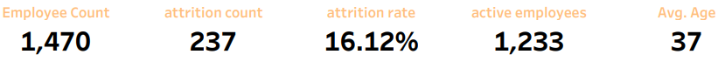

1. Attrition by Gender

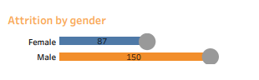

1. Department wise Attrition

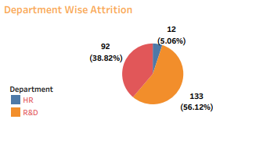

1. Number of Employees by Age Group

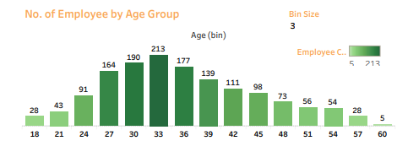

1. Job Satisfaction Rate

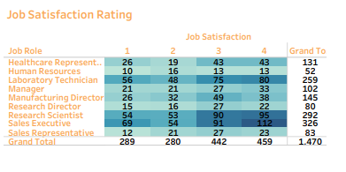

1. Education Field wise Attrition

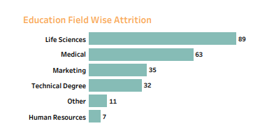

1. Attrition Rate by Gender for different Age Group

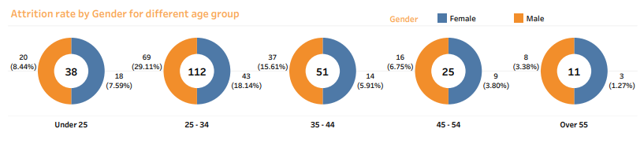

### DASHBOARD

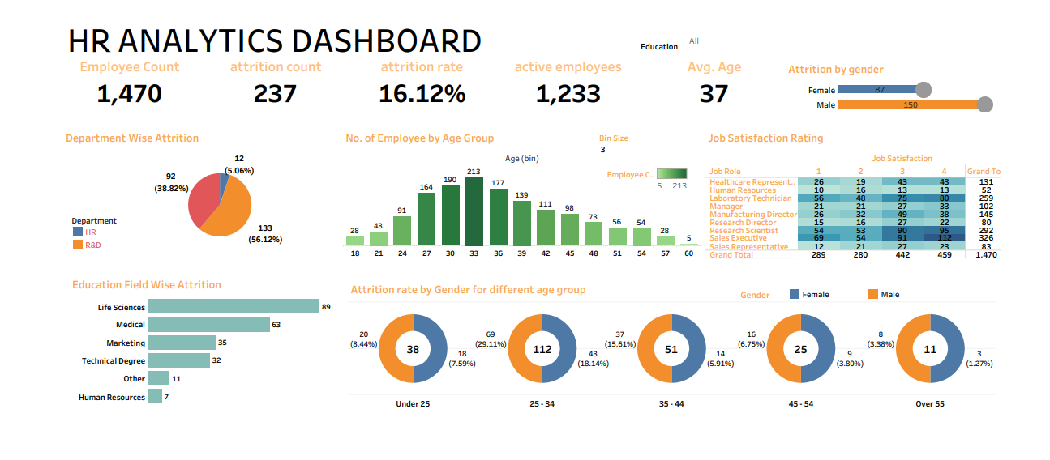

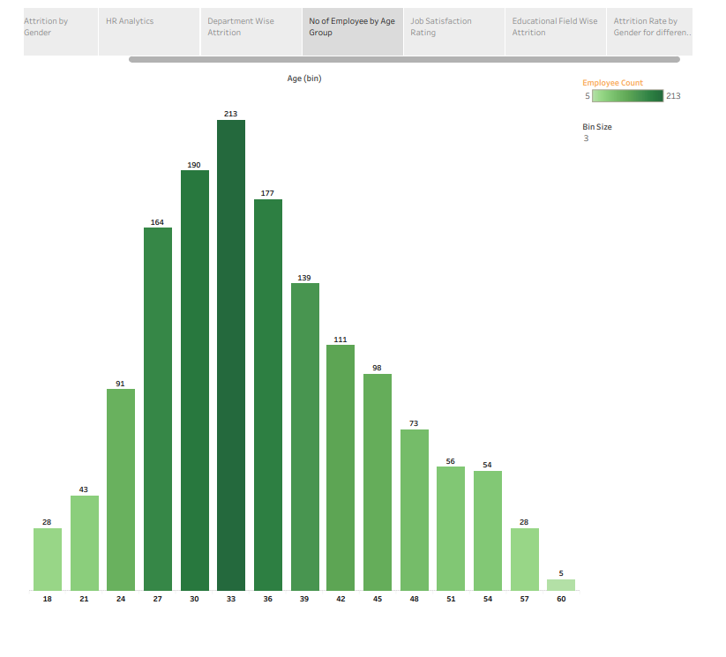In the created story line we have a total of 7 scenes showcasing the details of created worksheets.

[THE_TABLEAU_HR SCORECARD_MEASURING_SUCCESS_IN_TALENT_MANAGEMENT](https://public.tableau.com/views/sandy_16973658364260/HRANALYTICSDASHBOARD?:language=en-US&:display_count=n&:origin=viz_share_link)

### UTILIZATION OF DATA FILTERS

In every worksheet we can apply general or action filters based on input data provided to create visualisations. Based on these action filters the visualisations can be changed in certain aspects of categorisations (i.e., age, gender, departments etc.).

For an example, the below dashboard represents data without any filters.



Now if we apply an action filter based on the field of education, we can get data in accordance with the type of filter applied. The below dashboard represents data when filter is applied.

Now we can see that, our dashboard’s visualisations have been changed when we apply a filter in the field of education from all fields to employees with only bachelor’s degree.

This is one of the example for utilisation of filters.

LINKS TO ACCESS PROJECT FILES :

1. [GitHub Repository](https://github.com/SuryaPrahasan/The_Tableau_HR_ScoreCard_Measuring_-Success_in_Talent_Management_NM2023TMID25062/blob/main/DASHBOARD.pdf)
2. [Brainstroming Map](https://github.com/SuryaPrahasan/The_Tableau_HR_ScoreCard_Measuring_-Success_in_Talent_Management_NM2023TMID25062/blob/main/brainstorming%20Map.pdf)
3. [Empathy Map](https://github.com/SuryaPrahasan/The_Tableau_HR_ScoreCard_Measuring_-Success_in_Talent_Management_NM2023TMID25062/blob/main/Empathy%20Map.pdf)
4. [DashBoard](https://github.com/SuryaPrahasan/The_Tableau_HR_ScoreCard_Measuring_-Success_in_Talent_Management_NM2023TMID25062/blob/main/DASHBOARD.pdf) uploaded in github as pdf.
5. Tableau Public server -[Tableau Hr Scorecard : Measuring Success In Talent Management](https://public.tableau.com/views/sandy_16973658364260/HRANALYTICSDASHBOARD?:language=en-US&:display_count=n&:origin=viz_share_link)[.](https://public.tableau.com/app/profile/ajaykumar.s.k/viz/TableauHRScorecard-MeasuringSuccessinTalentManagement/HRAnalyticsDashboard)
6. [Story and Dashboard](https://public.tableau.com/shared/GST72W4RS?:display_count=n&:origin=viz_share_link%20https://public.tableau.com/views/sandy_16973658364260/HRANALYTICSDASHBOARD?:language=en-US&:display_count=n&:origin=viz_share_link)uploaded in github as pptx.
7. [Visualisation of sheets](https://github.com/SuryaPrahasan/The_Tableau_HR_ScoreCard_Measuring_-Success_in_Talent_Management_NM2023TMID25062/blob/main/1.KPI.pnghttps:/github.com/SuryaPrahasan/The_Tableau_HR_ScoreCard_Measuring_-Success_in_Talent_Management_NM2023TMID25062/blob/main/2.%20Attrition%20by%20Gender.pnghttps:/github.com/SuryaPrahasan/The_Tableau_HR_ScoreCard_Measuring_-Success_in_Talent_Management_NM2023TMID25062/blob/main/3.%20Department%20Wise%20Attrition.pnghttps:/github.com/SuryaPrahasan/The_Tableau_HR_ScoreCard_Measuring_-Success_in_Talent_Management_NM2023TMID25062/blob/main/4.%20No.%20of%20Employees%20by%20Age%20Group.pnghttps:/github.com/SuryaPrahasan/The_Tableau_HR_ScoreCard_Measuring_-Success_in_Talent_Management_NM2023TMID25062/blob/main/5.%20Job%20Satisfaction%20Rating.pnghttps:/github.com/SuryaPrahasan/The_Tableau_HR_ScoreCard_Measuring_-Success_in_Talent_Management_NM2023TMID25062/blob/main/6.Education%20Field%20Wise%20Attrition.pnghttps:/github.com/SuryaPrahasan/The_Tableau_HR_ScoreCard_Measuring_-Success_in_Talent_Management_NM2023TMID25062/blob/main/7.Attrition%20Rate%20by%20Gender%20for%20different%20Age%20Group%20-%20Copy.png)is uploaded in github as images compiled in a folder.

**ADVANTAGES**

1. **Visual Insights:** Tableau's data visualization capabilities allow HR teams to present complex HR metrics and KPIs in visually appealing and easy-to-understand dashboards, making it simpler to identify trends and patterns.

1. **Real-Time Monitoring:** Tableau enables real-time data updates, ensuring that HR professionals have access to the most current information, enabling them to make timely decisions.

1. **Data Integration:** Tableau can integrate data from various sources, such as HR software, employee surveys, and performance management systems, providing a holistic view of HR performance.

1. **Customization:** HR Scorecards can be tailored to an organization's specific needs, allowing HR professionals to focus on the metrics that matter most to their business objectives.

1. **Interactive Exploration:** Users can interact with Tableau dashboards to drill down into data, explore root causes, and gain deeper insights into HR-related challenges and opportunities.

1. **Enhanced Reporting:** Tableau allows for the creation of dynamic reports and presentations that can be shared with key stakeholders, facilitating data-driven discussions and decision-making.

1. **Efficiency:** By automating data collection and reporting processes, Tableau HR Scorecards save time and reduce manual effort, enabling HR teams to focus on strategic initiatives.

1. **Identifying Areas for Improvement:** HR Scorecards highlight areas of concern or underperformance, helping organizations address issues proactively and improve overall HR effectiveness.

1. **Alignment with Business Goals:** The ability to connect HR metrics to broader business objectives helps HR professionals demonstrate their impact on organizational success.

1. **User-Friendly:** Tableau's user-friendly interface makes it accessible to both technical and non-technical users, ensuring widespread adoption across the organization.

In summary, Tableau HR Scorecards empower HR professionals to leverage data effectively, optimize HR processes, and contribute to organizational growth and success through datadriven decision-making.

**DISADVANTAGES**

While Tableau HR Scorecards offer numerous benefits for visualizing and analyzing human resources data, there are also some disadvantages to consider:

* 1. **Cost:** Tableau licenses and implementation can be expensive, especially for smaller organizations with limited budgets.

* 1. **Complexity:** Creating and maintaining HR Scorecards in Tableau can be complex, requiring expertise in data analysis and visualization.

* 1. **Learning Curve:** Users may need time to learn how to use Tableau effectively, potentially slowing down the adoption process.

* 1. **Data Integration:** Integrating data from various HR systems and databases into Tableau can be challenging, especially if the data sources are not well-structured.

* 1. **Data Security:** Maintaining data security and privacy while using Tableau can be a concern, especially when dealing with sensitive HR information.

* 1. **Scalability**: Tableau may not scale well for very large datasets or organizations with extensive HR data.

* 1. **Limited Offline Access:** Tableau is primarily a web-based tool, which may not be ideal for users who require offline access to HR Scorecards.

* 1. **Maintenance:** Regular maintenance and updates are required to ensure that HR Scorecards remain accurate and relevant as HR data changes.

* 1. **Dependency on IT:** HR professionals may need to rely on IT support for technical issues and updates, creating a potential bottleneck.

* 1. **Customization Effort:** Creating customized HR Scorecards in Tableau can be timeconsuming, requiring ongoing effort to meet evolving HR reporting needs.

It's important to weigh these disadvantages against the benefits of Tableau HR Scorecards to determine if it's the right solution for your organization's HR analytics and reporting needs.

**APPLICATIONS**

The Tableau HR Scorecard project for measuring success in talent management has several valuable applications:

1. **Performance Tracking:** It allows HR teams to monitor individual and team performance metrics, such as employee turnover rates, productivity, and employee engagement, providing insights into the effectiveness of talent management strategies.

1. **Recruitment Optimization:** By visualizing recruitment data, organizations can identify which sources yield the best candidates, helping HR teams make informed decisions on where to invest their resources for talent acquisition.

1. **Training and Development:** The HR Scorecard can track employee training and development programs, assessing their impact on skill development and career progression, which is crucial for retaining and nurturing talent.

1. **Succession Planning:** It helps in identifying high-potential employees, tracking their development, and ensuring a robust pipeline for future leadership roles.

1. **Diversity and Inclusion:** The project can include diversity metrics, enabling organizations to measure progress in diversity and inclusion efforts and make necessary adjustments.

1. **Cost Control:** By visualizing HR costs related to talent acquisition, retention, and development, organizations can identify cost-saving opportunities and allocate resources effectively.

1. **Employee Satisfaction:** Employee feedback and satisfaction scores can be incorporated into the scorecard, giving HR teams insights into the overall well-being and happiness of the workforce.

1. **Strategic Decision-making:** The HR Scorecard facilitates data-driven decision-making by providing a comprehensive view of talent management metrics, helping organizations align HR strategies with broader business goals.

1. **Benchmarking:** Organizations can compare their HR metrics to industry standards or competitors, gaining insights into their competitive positioning in terms of talent management.

1. **Communication:** Visual dashboards and scorecards are effective tools for communicating HR performance to senior management and stakeholders, fostering transparency and accountability.

In summary, the Tableau HR Scorecard project plays a crucial role in measuring and enhancing success in talent management by providing actionable insights, facilitating informed decisionmaking, and ultimately contributing to the organization's overall performance and competitiveness.

## CONCLUSION

In conclusion, the HR Scorecard stands as a powerful and indispensable tool for modern organizations seeking to effectively manage and optimize their human resources functions. This strategic framework, inspired by the Balanced Scorecard concept, extends the traditional view of HR from a mere administrative function to a strategic partner in achieving overall organizational success. As the workforce landscape continues to evolve, organizations that harness the power of the HR Scorecard are better equipped to attract, develop, and retain top talent while contributing directly to their strategic objectives. By recognizing the strategic importance of HR and implementing the HR Scorecard, organizations can navigate the challenges of the modern business world with greater agility and achieve sustainable growth and success.

**FUTURE SCOPE**

The future scope of the Tableau HR Scorecard project is promising as it evolves to become an indispensable tool for measuring success in talent management. As organizations continue to recognize the critical importance of talent in achieving their strategic objectives, HR departments will increasingly rely on data-driven insights to optimize their talent management strategies.

In the coming years, the project can expand its capabilities to incorporate predictive analytics and machine learning algorithms, enabling HR professionals to forecast talent needs, identify highpotential employees, and proactively address workforce challenges. This predictive aspect can help in succession planning, reducing talent acquisition costs, and improving employee retention.

Moreover, as the workplace becomes more diverse and remote, the HR Scorecard can adapt by integrating metrics related to diversity and inclusion, employee engagement, and remote work effectiveness. This will enable organizations to foster a more inclusive work environment and support the changing dynamics of the workforce.

Furthermore, integrating external data sources, such as labor market trends and competitor benchmarks, can provide a broader context for talent management decisions, ensuring that organizations remain competitive in attracting and retaining top talent.

In summary, the future scope of the HR Scorecard involves incorporating advanced analytics, adapting to evolving workforce dynamics, and leveraging external data sources to create a holistic talent management tool. By doing so, it will play a pivotal role in helping organizations measure and enhance their success in talent management, ultimately contributing to their long-term growth and competitiveness.